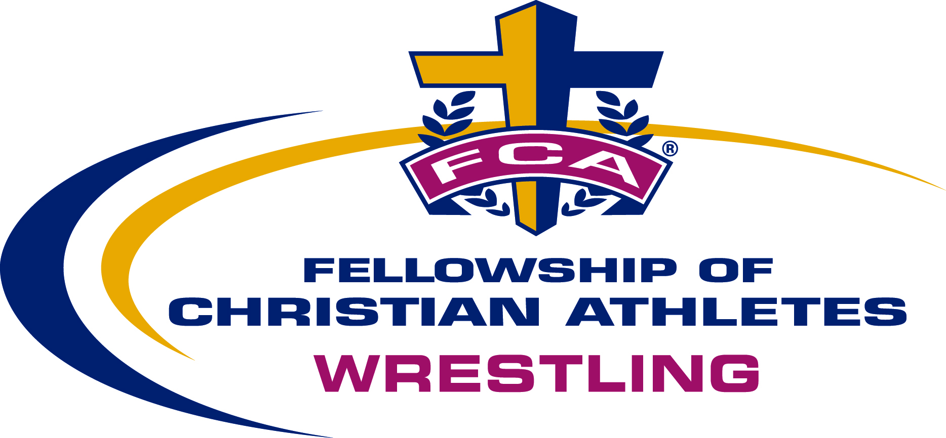

TEAM WRESTLING CAMP
Session One: June 8 - 11, 2014
Session Two: June 11 - 14, 2014
Shorter College
Rome, GA

Format: Each session of camp is a 3 night/ 4 day camp with world class clinicians, tough competition from around the Southeast, and an awesome FCA inspirational program. This camp is open to middle-schoolers!

Clinicians: One of the best coaching staffs in the nation: John Azevedo (NCAA Champion; ‘80 Olympic Team; coached Calvary Chapel H.S. to 7 CA state championships, recently retired Coach from “Cal Poly, San Luis Obispo”, America’s best takedown clinician); Mike McArthur (3x NCAA All-American; former Asst. Coach @ Oklahoma State & 1996 USA Olympic Team); Tom Ryan (2x NCAA All-American for the U. of Iowa, Head Coach for Ohio State University, 2009 “NCAA Coach of the Year”); Josh Henson (NCAA All-American for U. of Pennsylvania, Head Coach at Shorter College); Heath Eslinger (Coach @ UT-Chattanooga, 3x SoCon Champ).

Cost: Early discount price of $305.00/ wrestler, if registered by April 25th. $315 after April 25th. Price includes 3 nights lodging, 4 days of great technique training and competition, 9 meals, camp T-shirt, & FCA Bible.
**(Coaches bringing 10 or more wrestlers are free.)**

Deadline: Team Deposit of $500.00 due by April 25, 2014. (Wrestlers registering individually must have $75.00 deposit in by the same date.)
(All deposits are non-refundable, but a “substitution” may take a team’s/ wrestler’s place.)

**Note: $25.00 late fee / wrestler - after 5/22/13. Info for scholarships on website**
Camp space is limited to 200 wrestlers / camp session! Registrations taken on a “first-come/ first-served” basis. Directions, camp schedule, & final information will be sent to registered teams & wrestlers.

For more information, contact Bill Gifford (FCA Wrestling)
on his cell: (770) 364-2527, or email: bgifford@fca.org

2014 FCA Team Wrestling Camp
Team Registration Form
Session One: June 8 - 11, 2014
Session Two: June 11 -14, 2014
Shorter College, Rome, GA

School_____________________________________________________________

Contact Person______________________________________________________

Address____________________________________________________________

Home Phone:(___)___________Work:(___)____________Cell:(___)__________

Email______________________________________________________________
*******************************************************************
Indicate session you are attending:
Session One (June 8 – 11) _____; or Session Two (June 11 – 14) _____.

Indicate the age of your wrestlers: (High School ____or Middle-School____)

Please indicate the anticipated number of wrestlers and coaches:

Anticipated # of wrestlers:_________ Anticipated # of coaches:_________

Number & sizes of T-Shirts: Sm_____M_____L_____XL_____XXL_____XXX______

Signature___________________________________________________________
Head Coach Date
*Send this form, & team deposit of $500.00 (payable to FCA Wrestling), to:
FCA Wrestling Camp
Fellowship of Christian Athletes
P.O. Box 1510
Oakwood, GA. 30566

* $500.00 team deposit is due April 25, 2014 for discount price of $305/ wrestler. *
Price is $315 / wrestler for registrations received after April 25, 2014 ($340.00 /wrestler after May 22nd.)

For more information, or to register online, go to www.fcawrestlinggeorgia.org
FCA Wrestling • P.O. Box 1510 • Oakwood, GA • 30566 • Phone: 770-364-2527 • Email: bgifford@fca.org

2014 FCA Team Wrestling Camp
Shorter College, Rome, GA.
Individual Wrestler’s Registration Form

Name________________________________________________________________________

Address______________________________________________________________________

City______________________________________State___________Zip_________________

School_______________________________________________________________________

Grade (2014- 2015 School Year)______________Age_________Present Weight__________

Home Phone:(___)______________________Parent’s Work:(___)_____________________

Parent’s Cell:(___)___________________Parent’s Email:____________________________

Print Parent’s/ Guardian’s Name________________________________________________

Parent/ Guardian’s Signature___________________________________________________
Date
***Indicate which camp session you will be attending:
Session One: June 8 – 11, 2014 _____
Session Two: June 11 – 14, 2014 _____

Adult T-shirt size: Sm______ M______ Lg______ XL_______ XXL_______XXX______

Send registration form, & non-refundable deposit (payable to FCA Wrestling) of $75.00 to:
FCA Wrestling Camp
Fellowship of Christian Athletes
P.O. Box 1510
Oakwood, GA. 30566

* $305/ wrestler for registrations received by April 25, 2014 ($315 after 4/25.) *
**$25 late fee for all registrations received after May 22, 2014**
For more information, or to register online, visit our website www.fcawrestlinggeorgia.org
FCA Wrestling • P.O. Box 1510 • Oakwood, GA 30566 • Phone: 770-364-2527 • Email: bgifford@fca.org

